**GROUP 11 – PROJECT REPORT**

**Brand Name:** A&H

**Category:** Liquid Detergent

**Sales in Millions:** 7.4

**INTRODUCTION:**

Arm and Hammer is one of the leading brands of Liquid detergent in the U.S owned by Church & Dwight. In this project we have performed descriptive and statistical analysis with Arm and Hammer liquid detergent data and provided interpretations and insights that would be helpful for mangers to understand their customers better. We have also provided managerial recommendations based on the following three analysis.

**ANALYSIS 1: DESCRIPTIVE ANALYSIS**

1. Let us analyze the Liquid Detergent Market. We find the top 6 brands in terms of dollar sales. A&H stands 5th in liquid detergent market and its annual sales is almost 7.4 million.
2. We can calculate the market share of A&H considering that the top 5 brands constitute the market. Thus, Total Market = $ 89,393,029.9

Market Share of A&H = 8.28% (When only top 5 brands – Tide, ALL, Purex, Wisk and A&H constitute our market).

1. There are 33 parent companies that own Liquid Detergent brands. We find the top 5 in terms of dollar sales. Church & Dwight Co Inc owns brand A&H. It stands 3rd with a share of 11% in terms of dollar sales. Procter & Gamble owns almost half of the market and one of its leading liquid detergent brands is Tide.

1. Now let us find the top 10 markets that sell a lot in liquid detergent category.

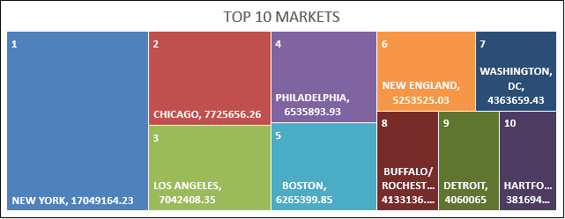

**ISSUE 1:** We find that A&H has such a low market share, about 8.28%. Its competitors Tide, ALL, Purex and Wisk are way ahead in the selling of Liquid Detergents. Especially, Tide contributes to more than half of the market share, whereas ALL, PUREX and WISK are close enough ranging in 12-15% each. We need to now analyze what factors affect dollar sales of A&H and what better are the competitors doing that A&H needs to improve upon. Also, we now know which markets are leading sellers of liquid detergents. So, A&H can target these markets and increase their displays here for more sales.

After studying the liquid detergent market, we find that some of the factors affecting customer’s preferences of buying could be product characteristics such as Flavor Scent, Concentration Level, Additives used, Average Display and Feature. Also, some of the customer characteristics such as family size, level of education and income could affect the sales of A&H. We further perform statistical analysis to provide concrete recommendations with respect to our findings in order to increase the sales, and thus increase the market share of A&H.

**ANALYSIS 2:**

**ISSUE 2:** As we know that the data exists for weeks 1114 to 1165, we can use such a rich data to forecast the future sales of A&H. Using the past data, the manager needs to have a prediction as to how the sales would look in the future quarters or weeks.

**TECHNIQUE USED:** We have used Time-Series Analysis to predict the future sales of A&H liquid detergent.

**VARIABLES USED:** Weeks 1114 to 1165 data and Dollar Sales.

**INTERPRETATION OF ESTIMATES:**

1. For time series analysis, the total dollar sales of Arm & Hammer were calculated for each week. A rough plot of the dollar sales values revealed a slightly decreasing trend, indicating that the revenue generated was decreasing over the year.
2. Next the series was tested for the presence of autocorrelation in error terms using Durbin-Watson statistic. The DW statistic value was around 2.08, indicating that there is no positive or negative auto correlation in error terms. This we confirmed using DWprob value. The t-test proved that the correlation was insignificant at 95% confidence.
3. No seasonality was observed in the plot. So, this indicated that there was only "trend component" which was contributing to non-stationarity. This is obvious because seasons do not affect the sales of detergents.
4. We run the Augmented Dickey Fuller test to check for the presence of non-stationarity. As expected, we found very low p values and hence rejected the null hypothesis that the series is non-stationary and confirmed that the series is stationary. So, we just must remove the trend component by taking differences.
5. Next we find the first differences to remove the trend effect. The ACF plot indicated that lags 1 and 2 were significant and PACF plot indicated that lag 1 was significant. So, this is ARIMA (1,1,2) model.
6. We then forecast the future values based on the current values. We had 1114 to 1165 weeks data, comprising of 52 weeks of a year. Now, the plot will show 53,54,55,56 and 57, these are the future weeks. It is found that though there is slight increasing trend in the future forecasts, the overall dollar sales were less than $150,000. This is very less when compared to Tide's dollar sales.

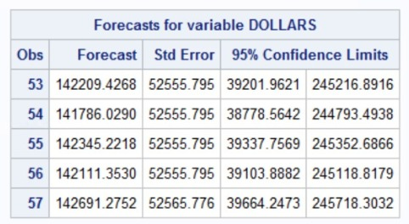

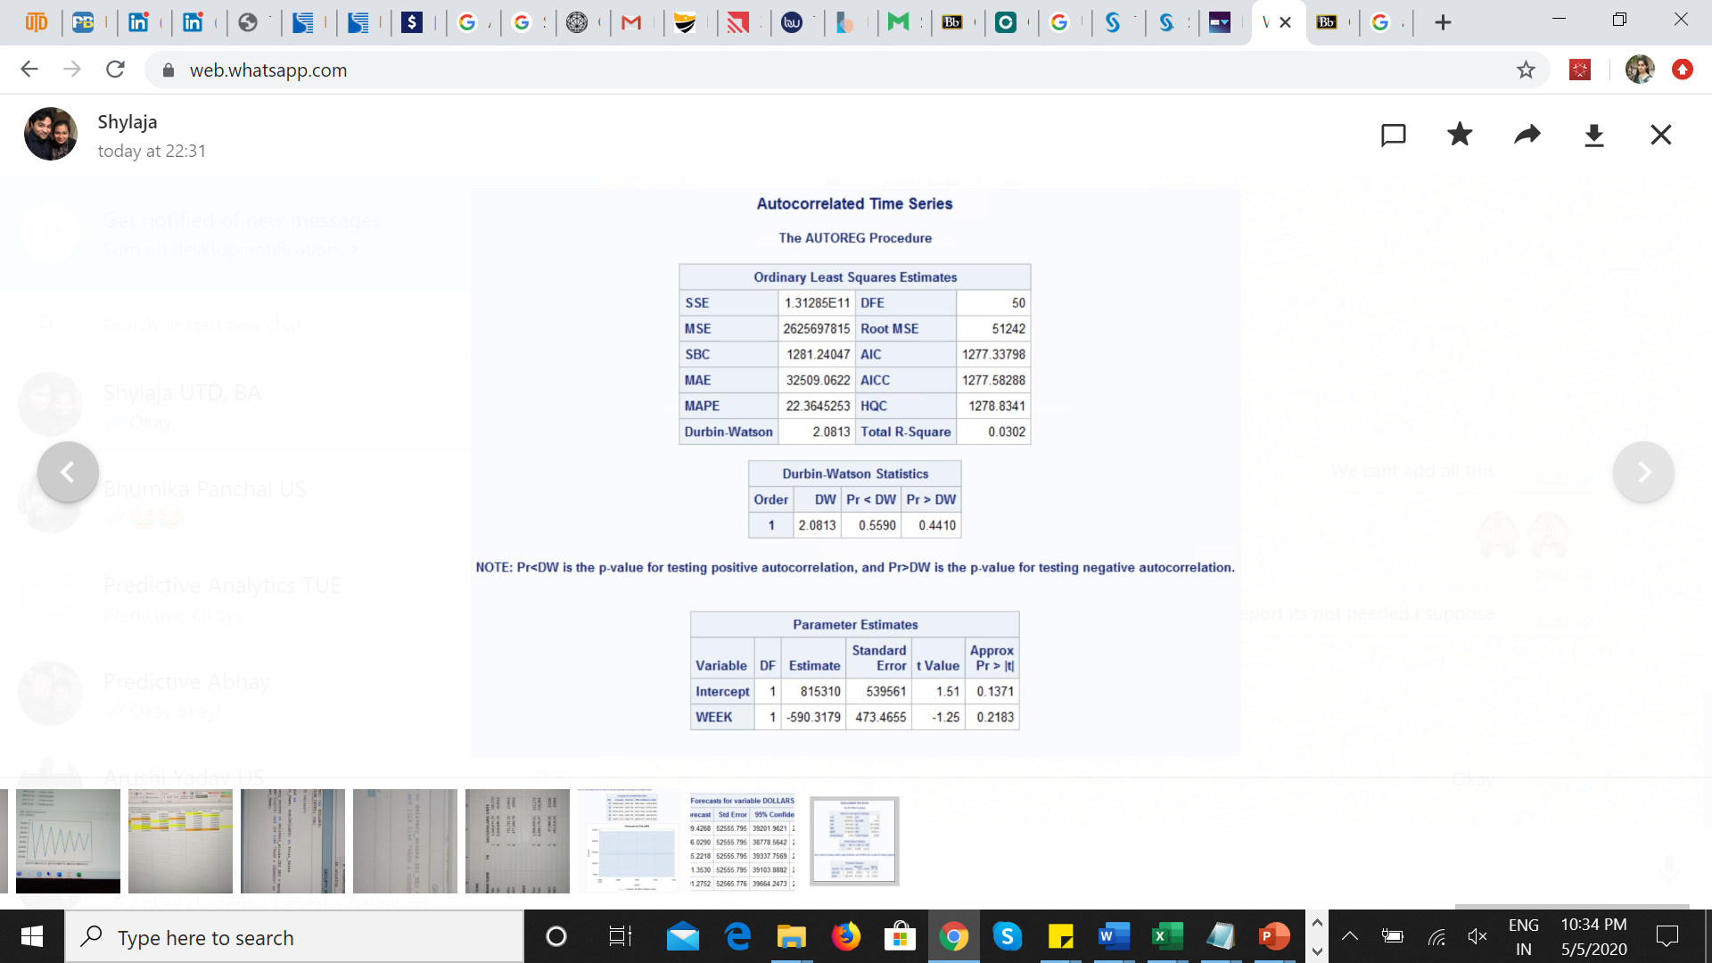

**ANALYSIS 3:**

**ISSUE 3:** We want to check how Price Reduction on a product affects the sales of A&H and also how it affects its number 1 competitor Tide across different markets. For instance, we considered the top 2 liquid selling markets – New York and Chicago and also the bottom 2 markets – Oklahoma City and Spokane. We computed the total dollar sales and units sold when PR=1 and PR=0.

**TECHNIQUE USED:** We have first used t-test to find out whether PR=1 is significantly differently from PR=0, that is whether giving price reductions have an effect on dollar sales of a brand. Once, we find out this, we have compared the dollar sales and units sold across 4 markets as mentioned above for Tide and A&H if PR matters.

**VARIABLES USED:** Price Reduction (PR) and Sum of Dollars

**INTERPRETATION OF ESTIMATES:** We found out that p<alpha (at 95% Confidence Interval), thus concluding that offering a price reduction or not affects the sales. Now, we have compared the sales and units sold across 4 markets for A&H and Tide and tabulated as below.

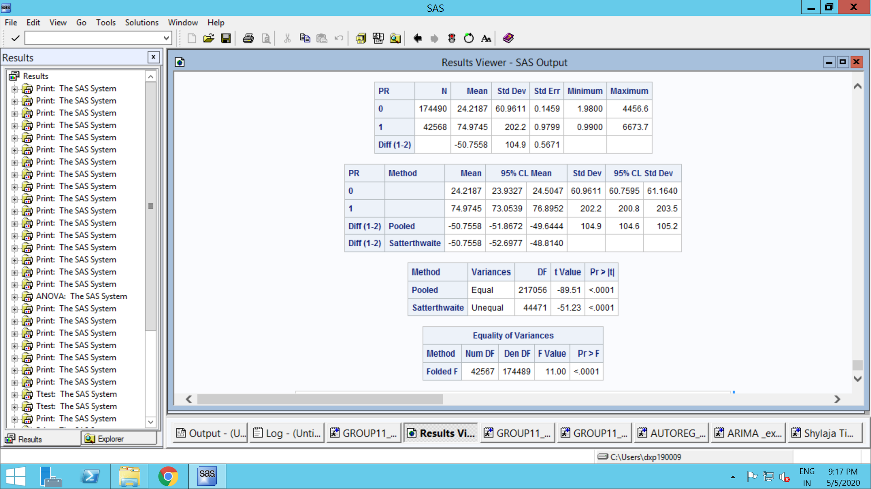

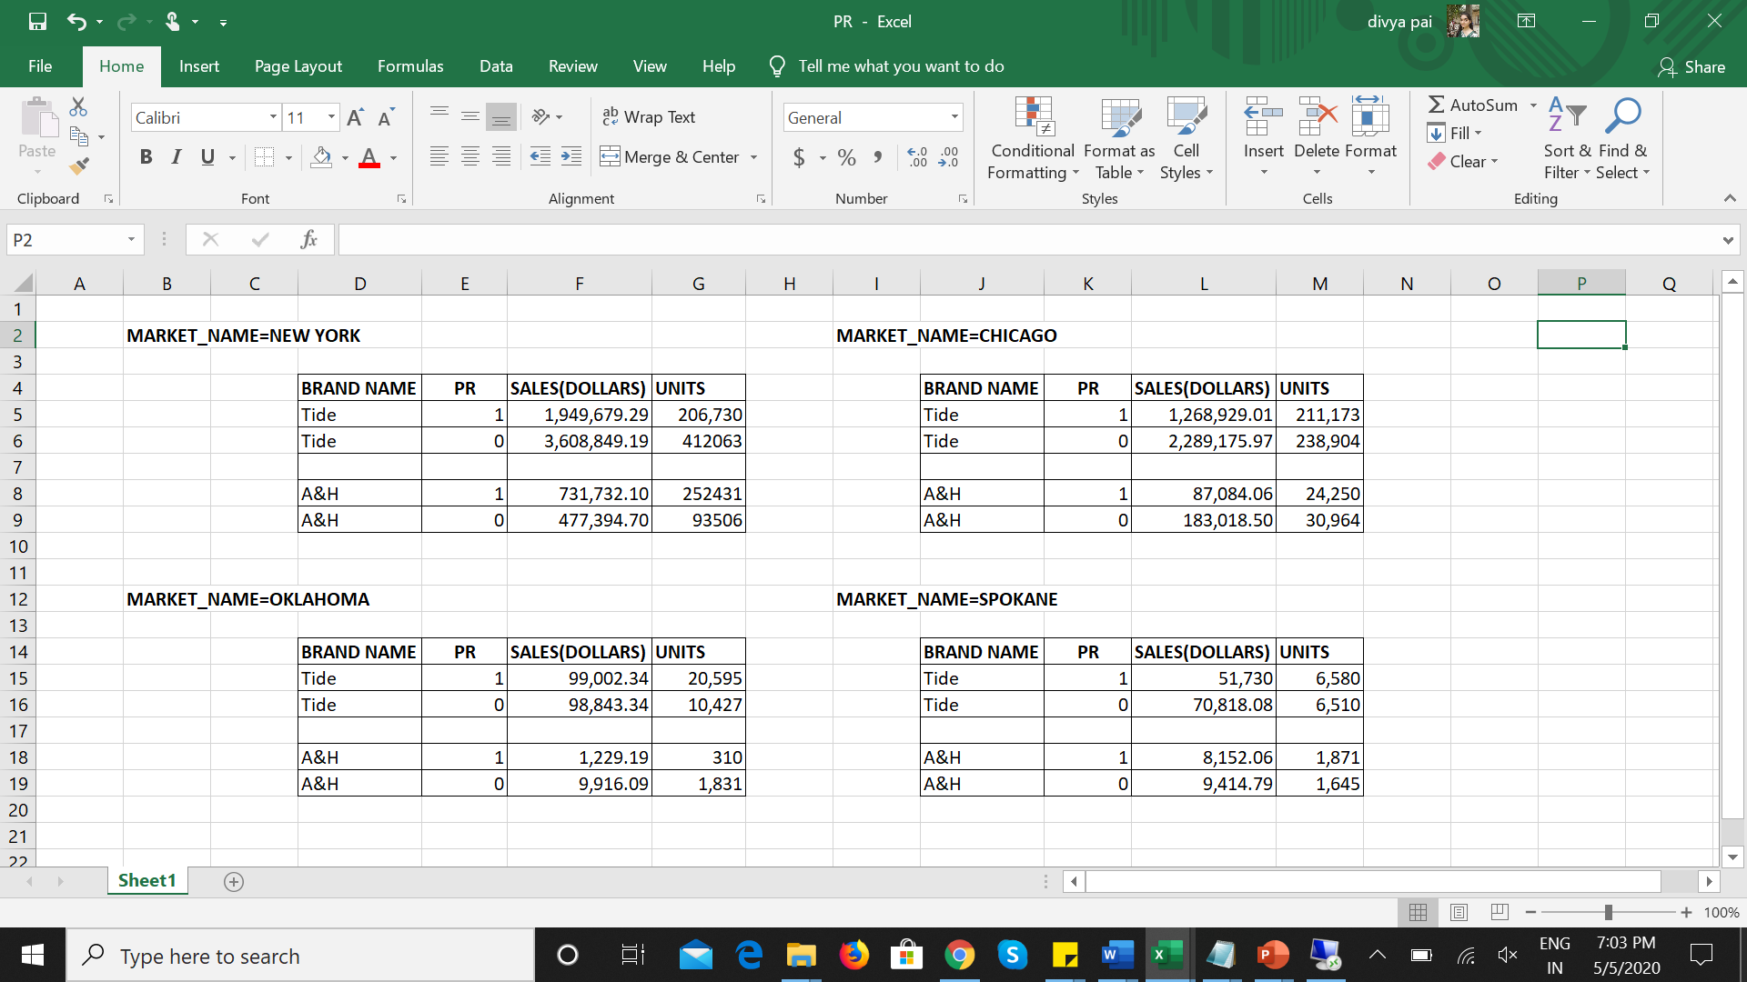

It is essential to note that in big markets like New York and Chicago where people are busy with their office works and fast lives, they are not worried about whether well-known brand like Tide offers a 5% or more price reduction or not. In fact, the number of units sold and so, sales are more for products with no price reduction offered as compared to products sold at a discounted price.

On the contrary, in cities like Oklahoma and Spokane where liquid detergents are not much in sale, more A&H detergents are sold when price reductions are offered. Almost same is the case for Tide.

**RECOMMENDATIONS:** In big cities like New York and Chicago, A&H should take the advantage of better lifestyles of people and thus, offer less discounts or rather no discounts if they are confident that people will buy their detergents anyways. This will help them improve their revenue generated. A&H can engage in non-price competition such as investing some amount in better, quick marketing strategies that people can look on-the-go while travelling, thus attracting more customers. By doing this, A&H can utilize the cost that were to be offered in bigger markets in smaller markets to increase brand awareness, and thus, its sales.

|  |  |  |  |
| --- | --- | --- | --- |
|  |  |  |  |

**ANALYSIS 4:**

**ISSUE 4:** To understand customer behavior impacting the sales of a detergent i.e. the factors of customer behavior which affects the sales like male_smokers, household education, household occupation etc. In order to better understand the customer behavior when it comes to liquid detergents, we have performed cluster analysis. In this process we will be able to identify customer characteristics which significantly, or insignificantly impact the sales of liquid detergents in that period.

**TECHNIQUE USED:** Cluster Analysis – Cluster analysis or clustering is the task of grouping a set of objects in such a way that objects in the same group (called a cluster) are more similar (in some sense) to each other than to those in other groups (clusters).

**INTERPRETATION OF ESTIMATES:**

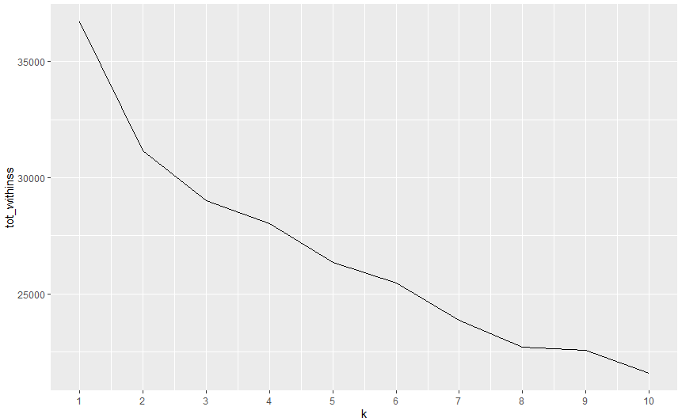

In order to perform cluster analysis, we have combined product_laundet data with grocery data which gives us the combined sales data of all the brands. This combined dataset has been combined with laundet_PANEL_GR dataset in order to obtain the PANID, which in turn will be used to combine with demographics data to do customer segmentation based on their characteristics. We have divided our customers based on their behavior into two categories using the elbow curve.



**Cluster 1:**

Units Bought: 55 Dollars Spent: 184 Dollar spent per unit: $3.34

**Cluster 2:**

Units Bought: 42 Dollars Spent: 158 Dollar spent per unit: $3.76

We observe that customers following in the first category are spending less money on detergents per unit every year. This can be attributed to various customer behavior like

|  |  |  |
| --- | --- | --- |
| **Clusters** | **Cluster 1** | **Cluster 2** |
| Income | $25,000 - $35,000 | $55,000 |
| Family Size | 2 - 3 | 4+ |
| Residential Possession | Owner | Owner |
| Age | 55+ | 35-44 |
| Education | High School Graduate | College Graduate |
| Occupation | Laborer/ Retired | Clerical |
| Number of Smokers | 1 | 2 |
| Number of Dogs | 0 | 1 |
| Number of Cats | 0 | 1 |
| Children Age Group | [5-17) | [0-5) – (12-17) |
| Marital Status | Married | Married/ Divorced |
| Number of TV’s (connected to cable) | 5(4) | 6(5) |
| Household Race | White | White/ Black (African American) |

From the above cluster analysis, we can observe the following:

**Having Pets (i.e. dogs or cats):** Customers with animals (i.e. dogs or cats) are willing to spend more on the detergent per unit, in order to make sure there are no animal hair on clothes or carpets etc.

**Income**: Customers with higher income are willing to spend more on detergent per unit, this makes sense since people with more money try to buy products which are of better quality

**Education**: Customers with higher education tend to choose more selective detergents, making conscious choice of selecting detergents which are made from better ingredients

**Children Age Group**: Customers who have infants tend to spend more on the detergents, since young kids tend to make their clothes dirtier in comparison to elder kids.

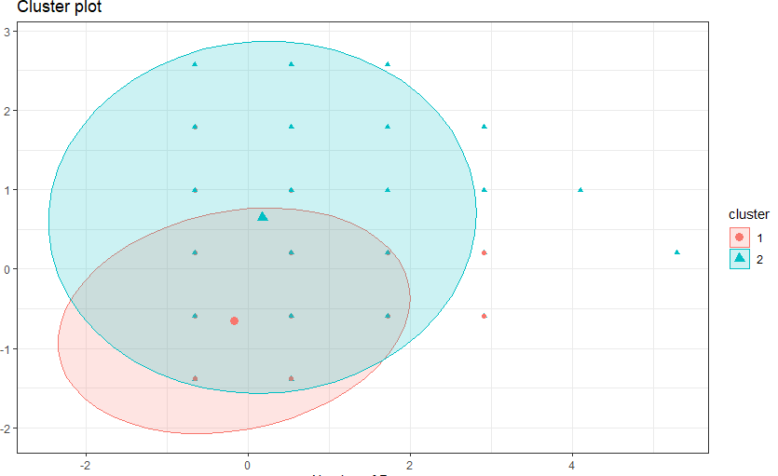

**RECOMMENDATIONS:**

From the above analysis, A&H can target the right customers based on their characteristics. Cities with more GDP have a better living culture, and thus customers usually buy products with no limit on their budgets. A&H can do an analysis on the placement of its liquid detergents maybe close to sections which sell pets products, so that people who have pets can easily find detergents placed next to them. They can also have their paper ads printed near these shelves.

**OVERALL RECOMMENDATION:**

As the brand manager of A&H, targeting the right customers and attaining brand loyalty is of utmost significance. Even with the presence of Tide as a strong competitor, A&H can improve upon its marketing strategies by targeting top selling markets. Also, as seen in cluster analysis, the marketing team can work better on the placement of its products in these stores. Finally, effectively use the discount strategies in places where the sales are less, and not in places like rich cities of North America where people are ready to invest in quality-products.